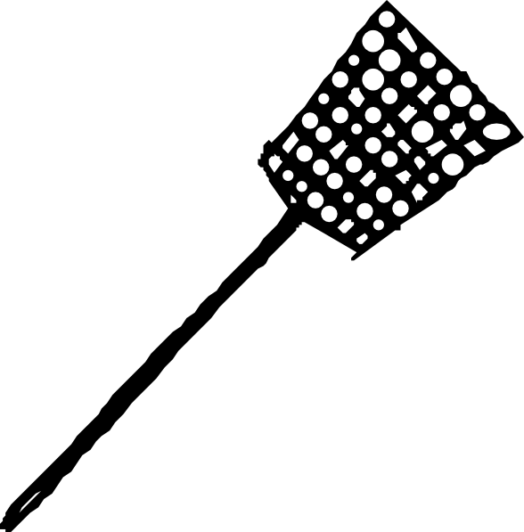Swat It!
Directions:
• 15-25 art vocabulary terms are drawn on a whiteboard or taped to a sturdy wall.
• Class is divided into two groups
• Two students at a time are “up to swat” and stand on an indicated line away from the wall/board
• A student reads out the definition of--or an example of—one of the displayed art terms.
• The two students must look for the word being described and “swat” it with their fly swatter
• Each team can shout and give hints and cheer, but the cheers must be positive and they cannot say the actual word
• There is no physical contact allowed, the fly swatters may touch, but no body is allowed.
• Once the term is swatted, the student must use the term in a descriptive sentence or find a work of art on the walls of the classroom that implement that word

