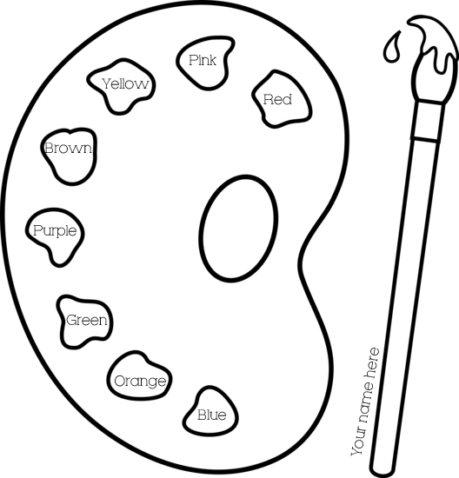

Step One: Color in the paint dabs with their labeled color

Step Two: Find a partner to be your “red” partner. REMEMBER for someone to be your partner for a certain color, you must be their partner for the SAME color

