Artist’s Statement for Mrs. Limkeman’s Studio

Artist Name: __________________________________ Period: ___________________ Date: ___________________
Parent/Guardians’ name: ___________________________________________________________________________
Where have you lived before (cities/states)? _____________________________________________________
Favorite color: _______________________________________________________________________________________
Favorite musical artist(s): __________________________________________________________________________
Favorite book(s): ____________________________________________________________________________________
Favorite movie(s): ___________________________________________________________________________________
Hobbies & Interests: _________________________________________________________________________________
_________________________________________________________________________________________________________
Favorite thing about art: ___________________________________________________________________________
_________________________________________________________________________________________________________
Two things you want to Learn in art this semester: ______________________________________________
_________________________________________________________________________________________________________
Do you work better in groups? Or alone? _________________________________________________________
How can I help you learn? __________________________________________________________________________
_________________________________________________________________________________________________________
_________________________________________________________________________________________________________What is one random fact about yourself that you want me to know? ___________________________ ________________________________________________________________________________________________________
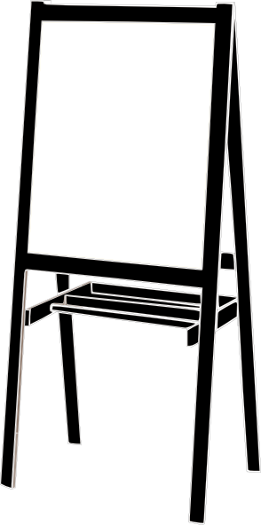
What sports/clubs/extra activities are you involved in? _____________________________________________________ _______________________________________________________
On the easel, draw the funniest looking face you can:

Welcome to Color & Design!

