Name:

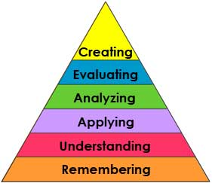
Period:
Date:

A thinking pyramid helps you start at the bottom to make answering the hard questions easier!
Start at the bottom by answering the questions in order:

Remembering
What was the purpose of reading this text/watching this video?
Define the main point of this text/video.
List at least three things you remember from the text/video.

Understanding
Describe something that surprised you.
Identify a problem/event/situation that the text/video is addressing.
Did you recognize any new concepts?

Applying
How can you apply what you learned today in your life this week?
Illustrate one thing you’ve learned and one thing you didn’t like.
Use at least three of the new concepts you learned in a sentence.

Analyzing
Compare and contrast something you knew with something that surprised you.
Examine one of the new concepts and how it relates to a work of art you’ve seen.
What was it about the concept that surprised you, that made you surprised?

Evaluating
What is something you disagree with? Why? Give supporting evidence.
How does what we’ve learned have value in your life?
What is something you agree with/enjoyed? Why?

Creating
Construct a work of art using one of the new concepts we’ve learned.
Develop a one page written critique of the text/video.
Use what you’ve learned and produce a new point of view either your own or what someone you know may think about this.

